If there is a problem during use, we first restore the factory settings to determine whether it is a hardware problem or a software problem during user use, and burn the factory firmware as follows: ESP32-CAM-MB_V4.0_2021-3-22

Burn the ESP32-CAM-MB development board

Unzip and open the burning software flash_download_tools_v3.6.8 as shown in the figure:
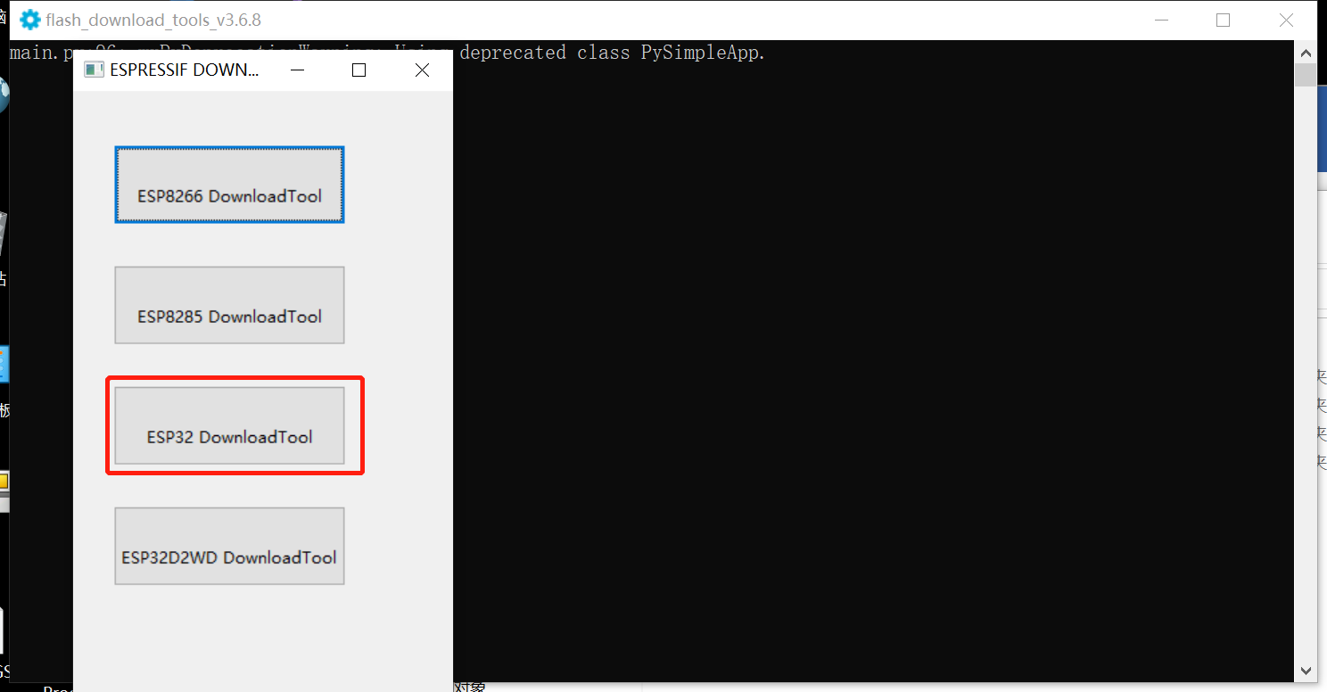

Select ESP32 DownloadTool and configure as shown in the figure (the firmware is in the data) and click START
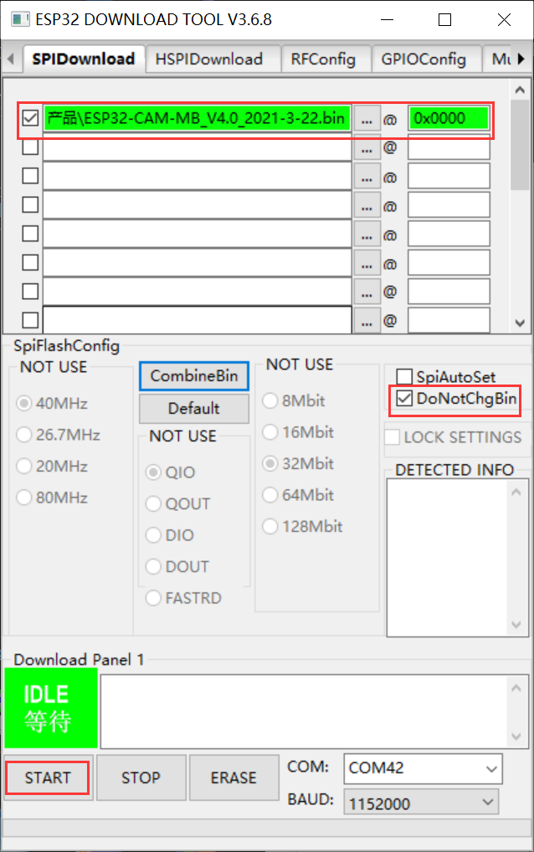

After the burning is completed, reset the development board, turn on the mobile phone WIFI, and use the mobile phone to connect to the "ESP32-CAM hotspot:

You can turn on the mobile phone WIFI, use the mobile phone to connect to "ESP32-CAM, and enter the 192.168.4.1 address.

Press the Start Streaming button to start video streaming. Press Get Still to take a photo, the photo will be stored in the sd card, and the name of the photo will be

machine naming
